**Self-Directed Learning Tools in USAF Cyber Education and Training**

Capt Nathaniel Flack1, Lt Col Mark Reith2

Department of Electrical & Computer Engineering, Air Force Institute of Technology, Dayton, USA

1[nathaniel.flack@afit.edu](mailto:nathaniel.flack@afit.edu)

2mark.reith@afit.edu

**Disclaimer:** The views expressed are those of the authors and do not necessarily reflect the official policy or position of the Air Force, the Department of Defense, or the U.S. Government.

**Abstract:**

The Air Force is currently conducting a complete overhaul of its education and training paradigm, shifting from multi-month face-to-face programs to a modular, agile, on-demand design. This new initiative, referred to as the Continuum of Learning, plans to leverage advanced learning and education tools to create and sustain life-long learners in the Air Force. This is a lofty goal that can only be obtained by developing systems that leverage both people and technology to promote Self-Directed Learning (SDL), a term coined by Malcolm Knowles in 1968. This paper describes the concept of SDL and explains its effectiveness in building and fueling life-long learners who can adapt to new situations and meet new challenges. This paper also examines the components of information technology tools that contribute to a user’s development as an SDL and encourages them to continue to reach new goals. Specifically, tools must be human-centered, intuitive, open, dynamic, and encourage collaboration. One emerging solution that contains basic forms of these elements is the Cyber Education Hub™(CEH™). This cloud-based learning tool is designed to present crowd-sourced content on an intuitive platform that encourages community engagement and feedback. The CEH™ is focused on providing cyber education to a broad spectrum of personnel in the armed forces. While this system addresses the unique challenges of cyber education and training, it has the potential to inform the design of future Continuum of Learning systems covering many functional areas. The paper concludes by posing a construct for a human subject research experiment and other suggestions for future study.

**Keywords:** Air Force education and training, Continuum of Learning, Self-Directed Learning, cyber education, Cyber Education Hub

**Introduction**

The Air Force is currently conducting a complete overhaul of its education and training paradigm shifting from multi-month face-to-face programs to a modular, agile, on-demand design. This new initiative, referred to as the Continuum of Learning, plans to leverage advanced learning and education tools to create and sustain life-long learners in the Air Force.

Many calls have been made for changes to the way the military conducts education and training. The Secretary of Defense, James Mattis, is one of these voices. He emphasized that the US Armed Forces need to “be prepared to deal with technological, operational, and tactical surprise, which requires changes to the way we train and educate our leaders and our forces…”[1]

Air Education and Training Command (AETC) is moving to meet these calls by implementing changes and adjusting resources to create the new Continuum of Learning.[2] Specifically, AETC wants to move learning from the classroom to self-learning or online course to the location where it is needed.

AETC is focusing on providing a Learning Ecosystem that will give users access to all the differing modes of training they need to do their mission. All of this training will be compiled in an Airmen Learning Record tracking all training, knowledge and skills possessed by the Airmen.[3]

According to AETC leadership, the overall goal of these efforts is to create learning effectiveness by creating and supporting lifelong learning.

Five initiatives have been developed and are currently being implemented:

1. Modularized Learning – current and future courses will be broken down into easily consumable learning modules.
2. Blended Learning – modalities (i.e. face-to-face, facilitated, and self-paced options such as self-study, simulations, games, exercises, group projects, etc.) will be combines to maximize learning effectiveness.
3. On-command and on-demand learning. Learning will require the achievement of some level of expertise and will provide avenues of learning for self-motivated learners.
4. Competency-based learning – the approach will be based on credentialing Airmen based on competencies gained through various education and training opportunities.
5. Airman’s Learning Record – a centralized record of all education and training an individual consumes along with all that an Airman knows and can do.

Figure 1 shows the concept of the learning ecosystem proposed by Lt Gen Roberson and Dr. Stafford in their description of the Continuum of Learning, which will center around, and be enabled by, the Learning Ecosystem at the center of the diagram.[4]

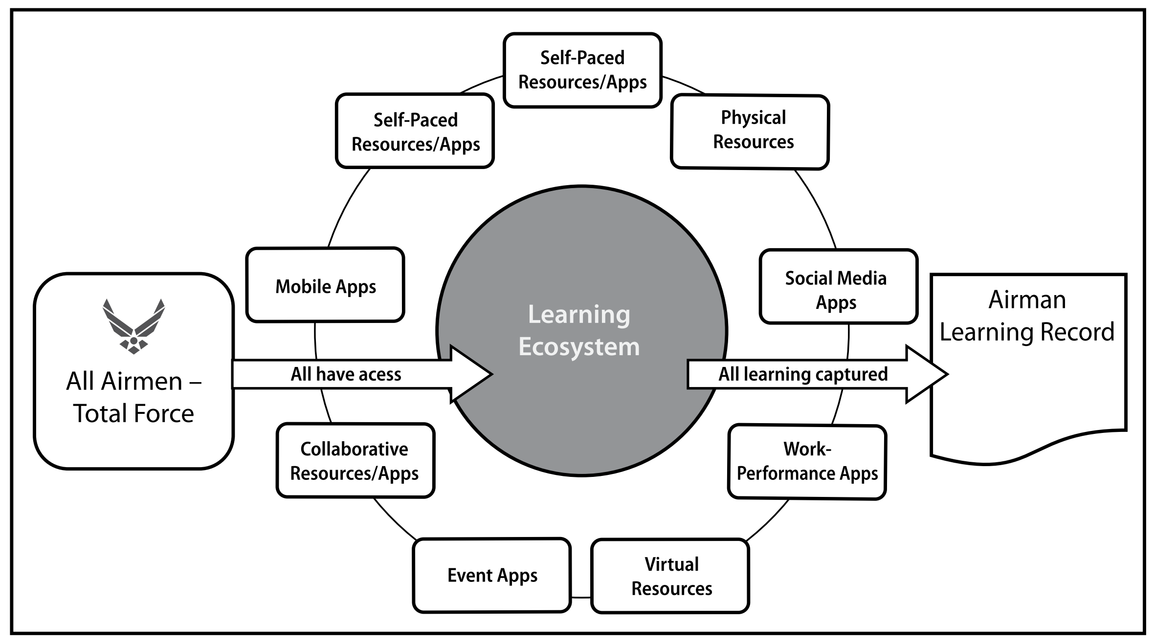

Figure 1. The New Air Force Learning Ecosystem

Additionally, the Army is focused on very similar goals. The *US Army Learning Concept for Training and Education for 2020-2040*, focuses on building a “learner-centric approach that creates lifelong learners through the use of technologically enhanced training, top-notch instructors and outcomes-focused – all delivered using a variety of mutually supportive modalities.”[5]

Both the Army and the Air Force have recently released refined education and training goals that seek to leverage technology to create lifelong learners.

Developing lifelong learners is a high goal. What is a lifelong learner? A simple definition is someone who continues to learn, not just in the beginning of life, but throughout their lifetime. The term carries with it the idea that one never arrives at a point where they know everything about a certain topic but continue to add to their understanding by making previously unknown connections. The lifelong learning is reaching out beyond what they know to discover the unknown. This idea is captured in the term *Self-Directed Learning*, made popular by Malcome Knowles in 1968.

**Self-Directed Learning**

Self-Directed Learning, as defined by Knowles (1975), is the practice of studying a subject without the explicit guidance of formalized education and training. Knowles focused his research and writing on educating adults, which he called andragogy, a term first used in the 1830s. He differentiated this from pedagogy which refers to the study of educating children. While volumes have been written on pedagogy, andragogy was mostly ignored as an academic discipline until the second half of the 1900s when it was popularized by Knowles in the English-speaking world.[6]

In his book titled *Self-Directed Learning*, Knowles (1970, p. 7) as quoted in Hase and Kenyon (2000) shifts the responsibility from the teacher to the learner:

“﻿Individuals take the initiative, with or without the help of others, in diagnosing their learning needs, formulating learning goals, identifying human and material re- sources for learning, choosing and implementing learning strategies and evaluating learning outcomes.”[7]

This shift is important because self-directed learners have three advantages. First, Knowles argues that people who take the initiative in their learning will experience a higher quality of learning and will learn more than someone who passively waits to be taught something. Second, self-directed learning is in line with natural psychological development. Knowles (1975, p. 15) as quoted in Hase and Kenyon (2000) writes, “An essential aspect of maturing is developing the ability to take increasing responsibility for our own lives – to become increasingly self-directed.” Lastly, Knowles held that student who possessed self-directed learning skills will experience less stress, anxiety, and frustration as well as provide greater success for both students and teachers.

Although Knowles distinction between how adults and children learn was important, current scholarship has shown that this needs to be taken to the next step. Hase and Kenyon (2000) hold that this next step is a revolution that “may have application across the whole spectrum of the education and learning lifespan.” This revolution takes into account the interconnected and rapidly changing world human inhabit in the 21 century. They write, “[a world in which] change is so rapid that traditional methods of training and education are totally inadequate;…modern organizational structures require flexible learning practices; and there is a need for immediacy of learning.”

In response to all of these various challenges, Hase and Kenyon propose a new term, Heutagogy, to help go beyond adult learning to truly self-directed learning. They define Heutagogy as the study of self-determined learning that emphasizes the holistic development of independent learning in the learner.

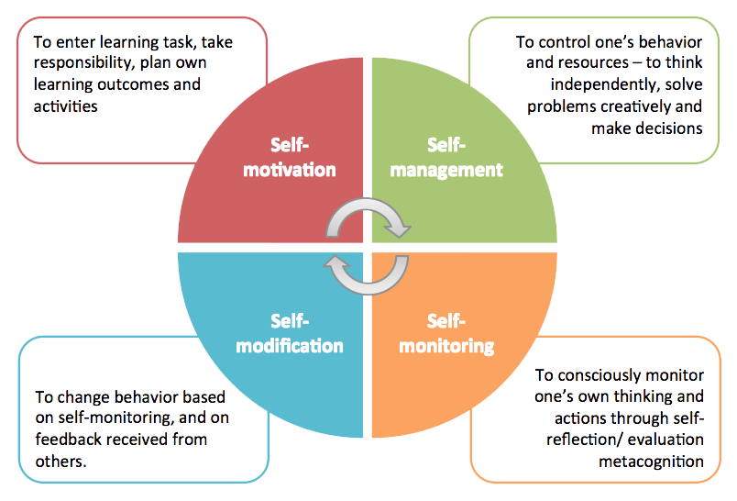

Figure 2. Four Areas of Self-Directed Learning[8]

Figure 2 shows four stages of self-directed learning that guide the learner through the learning process.

Hase and Kenyon write, “Heutagogy looks to the future in which knowing how to learn will be a fundamental skill given the pace of innovation and the changing structure of communities and workplaces.”

This analysis should inform the Air Force’s modern education and training transformation. Education and training in the 21st century needs to focus on teaching the learner how to learn and then providing the resources to fuel the learning process.

Blashchke (2012) proposes four design elements of self-directed learning experience that apply to both online and in-person learning environments.

1. Learner-defined contracts: This allows the learner to provide input on what will be learned and how it will be learned as well as what will be assessed and how it will be assessed.
2. Flexible curriculum: learners create their curriculum with instructors providing feedback and direction. This should focus on the upper limit of the learning instead of the minimum standard.
3. Learner-directed questions: questions posed by the learner become a key part of the learning process and help learners make sense of the world around them.
4. Flexible and negotiated assessment: The learner should be involved in designing his or her assessment. This has shown to improve the learners motivation and involvement in the entire learning process. Additionally, current research shows that self-assessment rubrics can be used effectively to assess learning. Areas such as “discussion skills, quality of work, outcomes, collaboration, academic soundness and knowledge of material” are suggested by Eberle (2008) as quoted in Balshchke (2012).

Writing in the year 2000, Hase and Kenyon were proposing the framework of Heutegogy on the verge of the vast expansions of the World Wide Web, and could probably not have foreseen the   
“Web 2.0” world of social media and instant information sharing. Technological advancements in electronics and communication have enabled self-directed learning to take place more effectively and on a larger scale.

**Technology and Personal Learning Environments:**

While many self-directed learning tools exist, both physical and electronic, the adaptability and connectedness enabled by the Internet has provided a huge boost to the viability of self-directed learning. While many electronic tools that can aid and enable SDL exist in educational institutions and other areas, there is not a clear leader in this area. In the discussion of SDL tools, one category of tools has emerged that are more tied to the learner than any specific institution or course. These tools are called Personal Learning Environments (PLE). Some examples of SDL tools are:

1. Google or Microsoft Online Accounts
2. Blogs
3. Microblogging (Popular examples are Twitter.com and Tumblr.com)
4. Resource/Image sharing (Instagram.com, Pinterest.com, Flickr.com, etc.)
5. Wiki (a website that allows collaborative editing, i.e. Wikipedia)
6. Personal website
7. Cloud storage account (Apple iCloud, Dropbox, etc.)
8. Social Bookmarking (Facebook.com, Pinterest.com, Reddit.com, etc.)

Hayworth (2016) outlines four key aspects for PLEs:

1. Easy to use. The tool must be intuitive or very easy to learn. Therefore, it must be developed with the user (learner) at the center.

2. Open. It must be able to extend and expand as relevant capabilities and plug-ins are desired.

3. Dynamic. The tool must contiguously adapt and grow as new requirements are defined. A quality PLE needs to “evolve according to the learners’ objectives and achievements.”

4. Provide collaborative options. The collaboration aspect of PLE’s provide powerful capabilities to connect SDLs to other SDLs to further research and create new connections.

**Self-Directed Learning and Military Training**

The military is facing the same challenges as the larger world that Hace and Kenyon describe. Therefore, the application of heutagogy and the practice of self-directed learning should be a key consideration in growing a force to operate in a 21st century environment. However, there are several aspects of SDL that will require more evaluation and testing before blind implementation.

One very obvious issue with SDL in a military context is that the needs of the military will almost always overshadow the goals of the learner. This is argued by Hiemstra (2011) who discusses the balance of learners’ goals with institutional goals. He writes, “in terms of university teaching, obviously some learning goals need to be set by an instructor or are established by standardized curricular decisions; however, decision-making by adults toward their own specific learning needs should be the goal. This speaks specifically to the university context, however the same is true for the military context. Commanders, trainers, and instructors will need to play a large roll in identifying student goals so that they are ready to accomplish the mission. This is a definite need where the operational competencies are known, and the goal of the training is to reproduce proven outcomes. However, as members of the military advance in their education, training, and operational experience they should be given more freedom to direct their own learning. This will be incredibly hard in the military environment where standardization, repeatable processes, and [blank] are highly valued. However, when self-directed learners are given freedom, proper stimuli, and tools for growth, they are poised to meet both today’s challenges as well as tomorrow’s unknown challenges.

In today’s complex operational environment, the warfighter will face challenges and problems where the solution is yet unknown. In these cases, the Self-Directed Learner will have the awareness and abilities to form new ideas and create new connections based on the information at hand leading to operational advantages.

America is very proficient at training warfighters to succeed in operational context that are well known and relatively predictable. Through repetition and discipline, military members are taught how to fight according to well-established tactics, techniques, and procedures that have worked in the past. We need this kind of training and discipline because it is one of the things that makes the US armed forces the best on the planet. However, we need to train these same warfighters to adapt and overcome when they face new problems and challenges that have never been seen before. How do you train someone for this? I would argue that you do not, you cannot, train them for this but must educate them and more importantly teach them how to learn so that when these new challenges arise they know to apply their knowledge, skills, and abilities to win. Nowhere in the military is this reality more obvious them in the domain of cyberspace.

**Self-Directed Learners in Cyberspace**

Developing lifelong learners is essential in the field of cyberspace because of the ever-increasing speed of technology change and the complexity inherent to the human-manipulated domain. In an article discussing the need to rethink US Air Force cyber education, Reith et al. discuss three broad challenges of cyber education and training . First, the ubiquity of cyber in every functional community creates a “scalability and breadth problem.” Cyber education needs to reach to all users, but also be specific to their functional community. Second, because cyberspace is a manmade and man-manipulated environment, it is changes at a higher rate than other science and technology fields, creating a huge “currency problem.” Third, the size and interconnectedness of cyber leads to a “complexity problem.” Many cyber topics require significant understanding of the cyber domain meaning the investment of time, energy, and resources to acquiring knowledge which might be mostly irrelevant to the problem at hand.

Self-Directed Learning can provide key advantages in the development, training, and education for operators in the cyber domain.

Self-Directed Learning provides a framework for personnel to set their own goals and objectives to make new connections that had not existed in the past. In a military context, this means operators can assemble concepts and skills gain in previous education and training experiences to meet and overcome current challenges.

SDLs are also lifelong learners which is another trait that must be present in those who understand and lead in the cyber domain. First, the continuous advancements in information technology and cyber forces leaders and operators to be continuously learning their craft. For example… [need more here]. Additionally, the laws that define other domains, such as the laws of gravity, aerodynamics, and physics that control objects in air and space, are not constant in cyberspace. A new technology can be invented and added to the network which can turn the current laws on their heads and create new operational challenges.

**The Cyber Education Hub**

The CEH framework, as the research team attests, “involves providing unprecedented self-ownership of an Airman’s education and training by allowing him or her to both consume and publish targeted, cyber content with respect to their mission set.” They sought to replicate content sharing and gamification sites such as YouTube, Netflix, etc. but also integrate elements that are essential for the military environment.

The cyber learning ecosystem they propose addresses the challenges of scalability, currency and complexity. First, it leverages cloud technology to enable access from Airmen across the globe. Second, it leverages crowd-sourcing by allowing user contributions from every unit and rank, creating a compilation of formal and informal content informed by education, training and operational experience. Last, the content is modularized to allows for learning to happen in smaller chunks at the time of need, while at the same time maintaining the relationships between the content using a “Topic Map.”[9]

The CEH implements many of the goals posed by AETC for its Continuum of Learning and Learning Ecosystem, and provides much functionality that can help an Airman develop as a self-directed learner. Below is a discussion of the features of an effective PLE and how they can be applied to the CEH to enhance its effect. Additionally, I propose a new capability be added to the current system to provide greater flexibility to the user in setting educational goals and organizing and sharing content.

Building on the framework offered by Reith et al. (2018) I suggest that the concepts of self-directed learning be integrated into the Cyber Education Hub (CEH) framework to help create and fuel lifelong learning. Hayworth’s criterial for effective Personal Learning Environments can provide insight to the development and sustainment of the CEH:

1. Easy to use. The CEH must continue to be developed and maintained with the user (learner) at the center. This is a key strength of the current system and is at the heart of the motivation behind its creation.

2. Open. It must be able to extend and expand as relevant capabilities and plug-ins are desired. However, because the CEH is designed for a military environment, openness needs to look different. If the CEH was open to non-DoD personnel and was able to be connected to different applications, there would be considerable risk of information spillage could quickly result in negative consequences. Therefore, restricting the CEH’s openness to DoD personnel is appropriate, and has the potential to expand cyber education and training well beyond its current communities.

Continued development of the CEH should consider the Learning Ecosystem framework proposed by AETC. They are planning for the system to be a one-stop-shop for all Air Force education and training resources, therefore, the CEH needs to ensure that it can be configured to plug-in to other resources in the military context that could enhance the user’s education. Users must not have to continue to duplicate information on multiple systems, but should have the benefit of having all education and training resources and records at their disposal.

3. Dynamic. A plan must be in place for the CEH to continue to grow and change as new requirements are defined. This means that the user should be able to define some layout and behavior features while keeping up with “look and feel” standards of advanced applications. This will mean more spending on on-going development; however, this is for more than just the aesthetics of the environment, but what will keep learners engaged in the CEH and coming back by choice.

4. Provide collaborative options. This is another key strength to the current CEH environment. All users are automatically a part of a learning community. Any content shared by one user is available to all. The CEH must continue to put collaboration at the center of its operating concept.

Another important aspect of the CEH that is not discussed by Haworth is longevity. Users must get the feeling that when they use the CEH, they are interacting with a tool that will still be there the day they retire. While the topics and content must be continually updating, the environment and relevant data must be accessible for the long-haul. PLEs must be available for users over their lifetime to be effective tools for life-long learning. If the user has to migrate to a new tool this means almost a completely new start. Additionally, they may lose valuable content they created or accumulated in the CEH.

**Enhancing the Cyber Education Hub**

The Cyber Education Hub represents a giant leap forward in education and training technology in the Air Force. By leveraging gamification techniques and crowd-sourced content it seeks to motivate users in a variety of ways, instead of just the “do it because it is required” mentality that is common throughout the military.

To best leverage the concepts of Self-Directed Learning and make a more effective personal learning environment for DoD personnel, the Cyber Education Hub should add a home page for each user that allows them to link content from across the CEH and the Web. In this way it would seek to replicate the functionality provided by a resource/social bookmarking site. The home page would be created so that users could add resources to a general category that is defined by the user. The user can then choose to share their categories so that others can add them to their homepage. This would both increase collaboration and multiply the benefits of the Topic Map and KSA Tree within CEH. As users find especially helpful resources, they can comment and recommend the resource, however, it might be hard for the user to find the resource in the future. If the users had a way to link that resource from their homepage it would categorize it for them. These categories would then be shareable to others who could leverage the efforts.

Benefits:

* Organize content based on individual preferences and categories
* Allow users to create their own education goal (much like KSA Trees) but without the top down structure of the KSA tree
* Allows any users to share a particular set of resources (like the topic map) that might be useful to a subset of users, however without the stringent topic focus of the topic map.
* The flexibility of the users home page to organize, link, comment, and share content along with the more controlled structure of the topic map and KSA tree will allow for both top-down and bottom up “course” development.
* Allow users to upload, organize, and share content that is not specifically related to cyber. This is a key aspect of Self-Directed learning that is not current captured by the CEH.

Examples:

* SymbalooEDU: This is a version of Symbaloo specifically designed for student/teacher interactions. On this platform teachers can build “webmixes” to share with students as a way of organizing content for students.

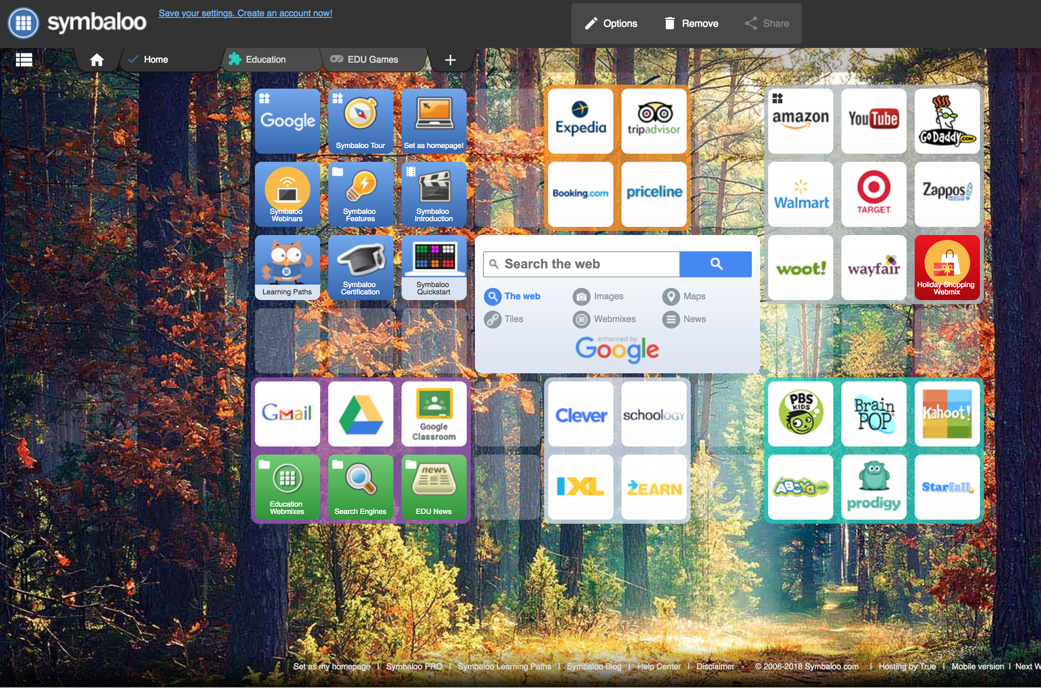

Figure 3. A Screenshot of a SymbalooEDU Webmix

* Pinterest: This platform, although mostly used by women for DIY projects across an array of subjects is useful to this discussion of military training because, like YouTube, is commonly used as a “how to” site. Users can post links to other content across the web and add their own comments to orient others to the benefit of that specific resource.

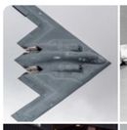

Figure 4. A Sample of Air Force Boards in Pinterest

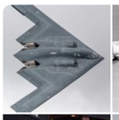

**Future Work**

I propose a framework for testing the effectiveness of the current tool next to a solution that implemented the proposed home page. The experiment would be best conducted in an operational unit where up-to-date training and education resources were needed and units provided/created their own training resources. The experiment would measure the amount of collaboration and user contributions would be evaluated as well as the number of categories created by the users and the number of items linked to those categories.

Addition research is needed to test the effectiveness of Self-Directed Learning in the military context. Specifically, how does the military need to develop its educators and trainers to best leverage SDL? What traits make a good SDL instructor? Current research shows that a lack of SDL skills in a learner cannot usually be overcome by a tool, therefore learners may need to be taught the discipline of SDL at the beginning or before being exposed to a tool. Is the place for military educators and trainers to teach people how to learn instead what to learn? Could this free up personnel to meet other challenges in our resource constrained environment?

Additionally, this line of research raises many questions about when a warfighter should be given the freedom to be a SDL. When should warfighters be given more freedom to set their own training goals? What are the dangers of this and how do we continue to provide robust guides and mentors to explain the expectations without negatively impacting their learning.

This paper touched briefly on flexible assessment strategies, but it has yet to be seen how this could be effectively executed within a military context. Can military commanders be assured that the member on the battlefield has the right skillsets and training to effectively execute the mission. Is there too much operational risk in removing uniform assessments in an environment that is built on standardization where each person is a replaceable cog in a larger system.

All these questions will be relevant as the Air Force and DoD move into a new age of education and training.

**Conclusion**

The Air Force is currently conducting a complete overhaul of its education and training paradigm shifting from multi-month face-to-face programs to a modular, agile, on-demand design. This new initiative, referred to as the Continuum of Learning, plans to leverage advanced learning and education tools to create and sustain life-long learners in the Air Force. This is a lofty goal that can only be obtained by developing systems that leverage both people and technology to promote Self Directed Learning. The concept of SDL can assist military educators to move members from pedagogy, to andragogy, and finally to heutagogy. The Air Force is at a unique time in history when technology is available to effectively and efficiently deliver education and training to vast numbers of users to enable their development and prepare them to adapt to the challenges ahead. The CEH is an emerging tool that has great potential and could be improved by integrating elements of quality SDL tools, often referred to as personal learning environments. Leveraging SDL in the cyberspace domain is critical because of the pace of technological change and speed of cyberspace operations. While this system addresses the unique challenges of cyber education and training, it has the potential to inform the design of future Continuum of Learning systems without a direct link to the cyberspace domain. Additionally, the research conducted on the CEH could inform the development of other systems both inside and outside the Department of Defense.

**References**

"Becoming a Self-Directed Learner." Lesson Planning: Centre for Teaching Excellence. April 2, 2017. Accessed November 19, 2018. https://cte.smu.edu.sg/learning-resources/self-directed-learning.

Blaschke, Lisa Marie. 2012. “Heutagogy and Lifelong Learning: A Review of Heutagogical

Practice and Self Determined Learning.” *The International Review of Research in Open and Distance Learning*. https://doi.org/10.1016/j.system.2004.09.015.

Chiaramonte, M.V., Howe, D.R., Collins, J.A. (2016) *Air Force CyberWorx Report 16-001: A 21st Century Training Model for Flexible, Quick, and Life-long Workforce Development*. USAF Academy, CO: CyberWorx.

Hase, Stewart, and Chris Kenyon, eds. *Self-determined learning: Heutagogy in action*. A&C Black, 2013.

Hase, Stewart, and Chris Kenyon. "From andragogy to heutagogy." *Ulti-BASE In-Site* (2000).

Haworth, Ryan. 2016. “Personal Learning Environments: A Solution for Self-Directed Learners.” *TechTrends* 60 (4): 359–64. https://doi.org/10.1007/s11528-016-0074-z.

Hiemstra, Roger. "Self-directed learning: Individualizing instruction–most still do it wrong." *International Journal of Self-Directed Learning* 8, no. 1 (2011): 46-59.

Hiemstra, R. Self-directed web portal. Accessed on 18 November 2018.

Merriam, Sharan B. 2001. “Andragogy and Self-Directed Learning: Pillars of Adult Learning Theory.”

Reith, Mark, Eric Trias, Chad Dacus, Seth Martin, and Landon Tomcho. "Rethinking USAF Cyber Education and Training." In *ICCWS 2018 13th International Conference on Cyber Warfare and Security*, p. 439. Academic Conferences and publishing limited, 2018.

Reith, M. (2016) “Forging Tomorrow’s Air, Space, and Cyber War Fighters: Recommendations for Integration and Development”, *Air & Space Power Journal*, Winter, Vol 30, No. 4, pp 96-107.

Roberson, D.L., Stafford, M.C. (2017) *The Redesigned Air Force Continuum of Learning*. Maxwell AFB, AL: Air University Press.

Shoemaker, D., Kohnke, A. (2016) “Cyber Education and the Emerging Profession of Cybersecurity” *EDPACS*, Vol 54, No. 5, pp. 12-16.

Smith, Mark K. *Malcolm Knowles, informal adult education, self-direction and andragogy*. The Encyclopedia of Informal Education, 2002.

Sobiesk, E., Blair, J., Conti, G., Lanham, M., Taylor, H. (2015) “Cyber Education: A Multi-Level, Multi-Discipline Approach” *Proceedings of the 16th Annual Conference on Information Technology Education,* pp. 43-47, October.

Tomcho, Landon, and Mark Reith. 2018. “Engaging Airmen with Cyber Education and Training.” *Journal of The Colloquium for Information System Security Education*, no. Winter: In Press.

Tomcho, Landon, Alan Lin, Mark Reith, David Long, and Mark Coggins. 2018. “Applying Game Elements of Cyber eLearning: An Experimental Design.” Air Force Institute of Technology.

US Air Force, “Cyberspace Operations Officer Career Field Education and Training Plan.” 2015. ﻿www.e-publishing.af.mil.

Weggeman, C. P. Personal correspondence. Used with permission. 11 January 2018.

Yannakogeorgos, P., Geis, J. (2016) *The Human Side of Cyber: Organizing, Training, and Equipping the Air Force Cyber Workforce*. Maxwell AFB, AL: Air University Press.

The Air Force, specifically, should use Heutagogy and Self-Directed Learning research to inform the development of the Continuum of Learning and the Learning Ecosystem to enhance the creation of lifelong learners.

America is very proficient at training warfighters to succeed in operational context that are well known and relatively predictable. Through repetition and discipline, military members are taught how to fight according to well-established tactics, techniques, and procedures that have worked in the past. We need this kind of training and discipline, especially early in a warfighters training, because it is one of the things that makes the US armed forces the best on the planet. However, we need to train these same warfighters to adapt and overcome when they face new problems and challenges that have never been seen before. How do you train someone for this? I would argue that you do not, you cannot, train them for this but must educate them and more importantly teach them how to learn so that when these new challenges arise they know to apply their knowledge, skills, and abilities to win.

SDL models will seem to work against the current culture in military environment where standardization, repeatable processes, and reproduction are highly valued. In almost all US military organizations each member is replaceable, which requires multiple people to have the same baseline training to perform a given task. This is one of the strengths of the US military enabled by its rigorous training programs. These strengths should not be discarded and still be widely used early on in the training programs for warfighters. However, in today’s complex operational environment of multi-domain operations, warfighters will face challenges where the solution is yet unknown. In these cases, the Self-Directed Learner will have the awareness and abilities to form new ideas and create new connections based on the information at hand, leading to operational advantages. Therefore, as members of the military advance in their education, training, and operational experience they should be given more freedom to direct their own learning. This will create warfighters who are poised to meet both today’s *and* tomorrow’s challenges. Nowhere in the military is this reality more obvious them in the domain of cyberspace.

a.  "This paper answers the question of what components are required in  
a learning tool to enable the development of people able to overcome  
obstacles and adapt to new challenges."  Are you proposing the components,  
or are you applying what Knowles advocated?  If the former, then you've got  
a good research paper.  If the latter, then it sounds like a book report.  
What I'd really like to know is how to apply SDL within the military  
context?  How do we need to tweak the aforementioned components?  Add/delete  
from the list?  Is the implementation the same for civilian students?  Why  
or why not?  
  
     b. What are the implications for relying on SDLs?  Under what specific  
conditions will SDL work in the military context (think cyber challenges)?  
How do we evaluate SDL Airmen?  How will we know our state of readiness?  
  
     c.  Recommend adding Tomcho's publications as references.  Call them  
technical reports until published.

--------------------------

Section on Army focused on SDL -- it seems that the tangent relating to the Army was just a tangent. It doesn't seem to be connected or to help provide emphasis on your argument. It seems that you are just including information regarding the Army, instead of supporting your notion that many people are looking at SDL as a modern option for learning, which I imagine is where you were trying to go with that.

The sections of **Technology and Personal Learning Environments** and **Self-Directed Learning and Military Training** -- it seems to just jump from one thought to another. It seems disjunctive. I think you should try to connect the two in a manner that shows how PLEs are oriented to SDL and Military Training, and lead in that way.

Reminder: You have "This will be incredibly hard in the military environment where standardization, repeatable processes, and [blank] are highly valued" where blank is not filled in. I would suggest interchangeability or interchangeable manpower. Just some off the top of my head.

Above the section **Self-Directed Learners in Cyberspace** -- I would change "Nowhere in the military is this reality more obvious them in the domain of cyberspace." change 'them' to 'than'.

In the first sentence of **Self-Directed Learners in Cyberspace** -- The phrase "Developing lifelong learners is essential in the field of cyberspace because of the ever-increasing speed of technology change and the complexity inherent to the human-manipulated domain" sounds a tad strange with the 'ever-increasing speed of technology change', I personally would change that to `ever-increasing speed of changing technology` or along those lines.

Overall, I really like it! Yes, there are paragraphs that are missing chunks, but you have the idea of each paragraph or idea on the paper and with that, I was able to see exactly where you wanted to go with that. Even without all the details, it was easily understood and I was able to follow the concepts that you were portraying. Personally, the concepts you use are made clear and concise. It is obvious you are trying to help the Air Force orient towards SDLs. Then, by utilizing the CEH in a manner directed towards that domain, attempt to better SDL styles for military training. I hope this feedback is useful to your research!

1. ﻿James Mattis, “Secretary of Defense Jim Mattis’ House Armed Services Committee Writ-

   ten Statement for the Record,” 12 Jun 2017, http://www.politico.com/f/?id=0000015c-9f04-d0 70-a57d-fffe4c600001, 7.
2. Roberson, Darryl L., and Matthew C. Stafford. 2017. “The Redesigned Air Force Continuum of Learning: Rethinking Force Development for the Future,” 17. http://www.aetc.af.mil/Portals/88/Documents/2018 AETC Strategic Plan - Final.pdf?ver=2018-02-09-110329-537.
3. Ibid., 11.
4. Roberson & Stafford
5. Ibid., 4
6. Knowles, Malcolm, Malcolm S Knowles, Malcolm Shepherd Knowles, United States, United States, and Malcolm Knowles. 2002. “Malcolm Knowles, Informal Adult Education, Self-Direction and Andragogy,” 3.
7. Stewart Hase and Chris Kenyon, "From andragogy to heutagogy," *Ulti-BASE In-Site* (2000), 2.
8. "Becoming a Self-Directed Learner," Lesson Planning: Centre for Teaching Excellence. April 2, 2017. Accessed November 19, 2018. https://cte.smu.edu.sg/learning-resources/self-directed-learning.
9. Reith, Mark, Eric Trias, Chad Dacus, Seth Martin, and Landon Tomcho. "Rethinking USAF Cyber Education and Training." In *ICCWS 2018 13th International Conference on Cyber Warfare and Security*, p. 439. Academic Conferences and publishing limited, 2018.